Main Content / Body

Definition:
# Source: AI Source: Provided by: [Data Path: Persons Table -> ID Column: 1, Name_En Column: Motasem Essam] -> From: [Chatgpt (GPT‑5 Mini)] on [2/12/2026]
The Main Content or Body of a web page is the central area where the primary information or content of the page is displayed. It’s the most important part because it contains what the user came to see.

Simple Definition
# Source: AI Source: Provided by: [Data Path: Persons Table -> ID Column: 1, Name_En Column: Motasem Essam] -> From: [Chatgpt (GPT‑5 Mini)] on [2/12/2026]
Main Content / Body = the part of a web page that shows the core information, like text, images, videos, or products.

What the Main Content / Body Usually Includes
# Source: AI Source: Provided by: [Data Path: Persons Table -> ID Column: 1, Name_En Column: Motasem Essam] -> From: [Chatgpt (GPT‑5 Mini)] on [2/12/2026]
- Text – articles, descriptions, instructions, or stories
- Images / Videos – support the content visually
- Links – related pages or references
- Lists / Tables / Graphs – organize data clearly
- Interactive elements – buttons, forms, or embedded media

Purpose of the Main Content / Body
# Source: AI Source: Provided by: [Data Path: Persons Table -> ID Column: 1, Name_En Column: Motasem Essam] -> From: [Chatgpt (GPT‑5 Mini)] on [2/12/2026]
- Deliver the key message of the page
- Engage and inform users with relevant content
- Support other components like header, footer, or sidebar
- Encourage user actions through calls-to-action (CTA)

Examples
# Source: AI Source: Provided by: [Data Path: Persons Table -> ID Column: 1, Name_En Column: Motasem Essam] -> From: [Chatgpt (GPT‑5 Mini)] on [2/12/2026]
- Blog → the blog post with text, images, and videos
- Product page → product description, specifications, and images
- Portfolio → projects with images and descriptions
- News website → articles with embedded media

Difference Between Main Content / Body and Header
# Source: AI Source: Provided by: [Data Path: Persons Table -> ID Column: 1, Name_En Column: Motasem Essam] -> From: [Chatgpt (GPT‑5 Mini)] on [2/12/2026]
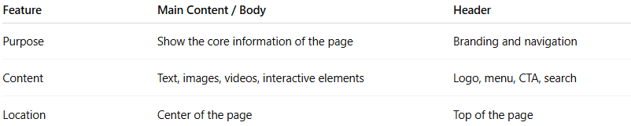
Feature | Main Content / Body | Header
Purpose | Show the core information of the page | Branding and navigation
Content | Text, images, videos, interactive elements | Logo, menu, CTA, search
Location | Center of the page | Top of the page

